

**Mini Project Report**

**On**

**“Dry and wet segregation”**

**By**

**Shrikant Hadpad**

**Tejas Patil**

**Abhishek Kolekar**

**Sagar Raghoji**

Under the guidance of

**Ms. A.N. Shaha**

**Government College of Engineering, Karad**

**Bachelors of Technology Degree in Electronics and Telecommunication**

**2021 - 22**



**SHIVAJI UNIVERSITY KOLHAPUR, MAHARASHTRA - 416004.**

**CERTIFICATE**

This is to certify that the dissertation entitled **“Dry and wet segregation”**

**Submitted by,**

**Shrikant Hadpad**

**Tejas Patil**

**Abhishek kolekar**

**Sagar raghoji**

Is a record of bonafide work carried out by him under my Guidance, in partial fulfilment of the requirement for the award of the Degree of Bachelors of Technology (Electronics and Telecommunication) of Government College of Engineering, Karad in the academic year

2021 – 2022.

Date:-

Place: - Karad.

**Dr. Ms. S.R Kulkarni Prof. Ms. A.N. Shaha**

**(Head of Department) (Guide)**

Dept. Of Electronics & Telecomm. Dept. Of Electronics Telecomm.

GCE, Karad GCE, Karad

**Dr. A.T. PISE**

(Principle)

Government College of Engineering, Karad

**DECLARATION**

We

**Shrikant Hadpad**

**Tejas Patil**

**Abhishek Kolekar**

**Sagar Raghoji**

Hereby declare that the Project Report entitled,

**“Dry and Wet Segregation”**

Done by our group under the guidance of Project guide and External Examiner In partial fulfilment of the requirement for the award of the Degree of Bachelors of Technology (Electronics and Telecommunication) of Government College of Engineering, Karad in the academic year 2021 – 2022.

**Prof. Ms. A.N. Shaha** External Examiner

Project Guide

GCE, Karad

**ACKNOWLEDGEMENT**

We take this opportunity to express my deep sense of gratitude and sincere thanks to **Dr. A.T. PISE (Principle)**, Government College of Engineering, Karad without whom this work was impossible. This continuous encouragement and support helped me throughout. We would like to thank to my project guide **Prof. Ms. A.N. Shaha,** under their guidance, constant source of encouragement, support and motivation this project was carried out. He provided me all resources and generous help and technical matters at all points of time. And more than that trust he kept upon me more than myself. We would also like to thank **Dr. Ms. S.R Kulkarni (Head of the Department)** of Government College of Engineering, Karad for giving invaluable suggestions. We would like to thank my classmates& friends for being with me all the times in odds and evens phases of life. Whose direct and indirect support and sincere advice brought me to achieve this? We are very much thankful to all teaching and non-teaching staff members of Government College of Engineering, Karad who were directly and indirectly involve in my project work. We wish to thank our **Family and Friends** for having raised me in such conducive and loving environment, for teaching me how consciousness can emerge from sub symbolic computation, for inspiring me to study connectionism which has enabled me to come so far. They helped me in a long way throughout the project phase; this forced me to limit and brought forward the best in me.

**ABSTRACT**

Rapid increase in volume and types of solid and hazardous waste due to continuous economic growth, urbanization and industrialization, is becoming a burgeoning problem for national and local governments to ensure effective and sustainable management of waste. It is estimated that in 2006 the total amount of municipal solid waste generated globally reached 2.02 billion tones, representing a 7% annual increase since 2003 (Global Waste Management Market Report 2007). The segregation, handling, transport, and disposal of waste needs to be properly managed to minimize the risk to the health and safety of patients, the public, and the environment. The economic value of waste is best realized when it is segregated. Currently, there is no such system of segregation of dry and wet wastes at the household level. This paper proposes Dry and Wet Garbage Segregator which is a cheap, easy to use solution for a segregation system for household use, so that it can be sent directly for processing. It is designed to sort the refuse into wet waste and dry waste. The Experimental results show that the segregation of waste into wet and dry waste has been successfully implemented using the Dry and Wet garbage Segregator. Dry and wet waste segregator which is a cheap, easy to use solution for a segregation system at households, so that the wastes can be sent directly for processing. Redesigning old dustbin into multipurpose system to fulfil peoples need and requirements. We believe that this model can change community’s mind set to throwing the garbage.

**CONTENTS**

|  |  |  |  |
| --- | --- | --- | --- |
| **Sr. No.** | **Name of Part** | | **Page Number** |
|  | 1. | Certificate | ii |
| 2. | Declaration | iii |
| 3. | Acknowledgement | iv |
| 4. | Abstract | v |
| 5. | Content | vi |
| 6. | List of figure | vii |
| 7. | List Of Abbreviations | viii |
| 1. |  | Introduction | 1-4 |
|  | 1.1 | General | 1 |
| 1.2 | Motivation | 3 |
| 1.3 | Objective | 3 |
| 1.4 | Provided Solution | 4 |
| 2. |  | Aim and Scope | 5-6 |
|  | 2.1 | Aim Of Project | 5 |
| 2.2 | Scope Of Project | 6 |
| 3. |  | Project Description | 7-8 |
|  | 3.1 | System Flowchart | 7 |
| 3.2 | System circuit & block diagram | 8 |
| 4 |  | Hardware used | 10-22 |
|  | 4.1 | Raspberry pi | 10 |
| 4.2 | Moisture sensor | 15 |
| 4.3 | Servo motor | 17 |
| 4.4 | IR sensor | 19 |
| 4.5 | Breadboard & jumper wire | 22 |
| 5. |  | Software used | 23-24 |
|  | 5.1 | VNC | 23 |
| 5.2 | Advance IP Scanner | 24 |
| 5.3 | balenaEtcher Portable-1.5.122 | 24 |
| 6. |  | Result | 25-27 |
|  | 6.1 | Methodology | 25 |
| 6.2 | Code | 25 |
| 6.3 | Output | 27 |
| 7. |  | Conclusion | 28 |
| 8. |  | References | 28 |

**LIST OF FIGURES**

|  |  |  |
| --- | --- | --- |
| **Sr. No**. | **List Of Figure** | **Page Number** |
| 1. | System Flowchart | 7 |
| 2. | Block Diagram | 8 |
| 3. | Circuit Diagram | 9 |
| 4. | Raspberry Pi | 10 |
| 5. | Introduction to raspberry Pi | 11 |
| 6. | Pin configuration | 12 |
| 7. | Moisture Sensor | 15 |
| 8. | Servo Motor (Sg90) | 17 |
| 9. | IR Sensor | 19 |
| 10. | Infrared LED | 20 |
| 11. | IR Receiver | 21 |
| 12. | IR Sensor structure | 21 |
| 13. | Breadboard | 22 |
| 14. | VNC | 23 |
| 15. | Advance IP Scanner | 24 |
| 16. | balenaEtcher- Portable | 24 |
| 17. | Terminal Window Output | 27 |
| 18. | Hardware Output | 27 |
|  | | |

**LIST OF ABBREVIATIONS**

1**. IDE –** Integrated Development Environment

2**. VCC** – Voltage Common Collector

3**. GND** – Ground

4. **GPIO** – General purpose input / output.

5. **RX** –Receive.

6. **TX** – Transmit.

**1) INTRODUCTION**

**1.1 General**

Solid waste management (SWM) is a major problem for many urban local bodies (ULBs) in India, where urbanization, industrialization and economic growth have resulted in increased municipal solid waste (MSW) generation per person. Effective SWM is a major challenge in cities with high population density. Achieving sustainable development within a country experiencing rapid population growth and improvements in living standards is made more difficult in India because it is a diverse country with many different religious groups, cultures and traditions. Despite significant development in social, economic and environmental areas, SWM systems in India have remained relatively unchanged. The informal sector has a key role in extracting value from waste, with approximately 90% of residual waste currently dumped rather than properly landfilled. There is an urgent need to move to more sustainable SWM, and this requires new management systems and waste management facilities. Current SWM systems are inefficient, with waste having a negative impact on public health, the environment and the economy. The waste Management and Handling Rules in India were introduced by the Ministry of Environment and Forests (MoEF), although compliance is variable and limited. This paper reviews the challenges, barriers and opportunities associated with improving waste management in India. It is the output from an international seminar on ‘Sustainable solid waste management for cities: opportunities in SAARC countries' organized by the Council of Scientific and Industrial Research-National Environmental Engineering Research Institute (CSIR-NEERI) and held in Nagpur, India in 2015. SAARC is the South Asian Association for Regional Cooperation and includes Bangladesh, Bhutan, India, Maldives, Nepal, Pakistan, Sri Lanka and Afghanistan.

Waste management rules in India are based on the principles of "sustainable development", "precaution" and "polluter pays". These principles mandate municipalities and commercial establishments to act in an environmentally accountable and responsible manner—restoring balance, if their actions disrupt it. The increase in waste generation as a by-product of economic development has led to various subordinate legislations for regulating the manner of disposal and dealing with generated waste are made under the umbrella law of Environment Protection Act, 1986 (EPA). Specific forms of waste are the subject matter of separate rules and require separate compliances, mostly in the nature of authorisations, maintenance of records and adequate disposal mechanisms. With rapid urbanisation, the country is facing massive waste management challenge. Over 377 million urban people live in 7,935 towns and cities and generate 62 million tonnes of municipal solid waste per annum. Only 43 million tonnes (MT) of the waste is colcted, 11.9 MT is treated and 31 MT is dumped in landfill sites. Solid Waste Management (SWM) is one among the basic essential services provided by municipal authorities in the country to keep urban centres clean. However, almost all municipal authorities deposit solid waste at a dumpyard within or outside the city haphazardly. Experts believe that India is following a flawed system of waste disposal and management. The key to efficient waste management is to ensure proper segregation of waste at source and to ensure that the waste goes through different streams of recycling and resource recovery. Then reduced final residue is then deposited scientifically in sanitary landfills. Sanitary landfills are the ultimate means of disposal for unutilised municipal solid waste from waste processing facilities and other types of inorganic waste that cannot be reused or recycled. Major limitation of this method is the costly transportation of MSW to far away landfill sites. A report by IIT Kanpur (2006) found the potential of recovering at least 15 per cent or 15,000 MT of waste generated every day in the country. This, the report said, could also provide employment opportunities to about 500,000 rag-pickers. The report added that despite immense potential in big cities in this area, participation from non-profits or community is limited. In some urban centres, people working in the informal sector collect solid waste for each doorstep to get a collection fee and derive additional income from sale of recyclables. The informal recycling industry plays a major role in waste management. It also ensures that less waste reaches landfills.

On being asked as to why a waste-to-energy (WTE) plant is required for the city, an official of an urban local body said, “It is a clean and productive way of getting rid of the city garbage and companies will be financing from installation of the plant to segregation, it will be their problem to tackle it for our city.”

This is the fundamental issue with waste management in India. It is someone else’s problem. A number of WTE plants have either come up or proposed in India over the past few years. There are currently five such plants with a cumulative installed capacity of 66.5 MW that are currently operational/under trial run in the country. In addition, the Ministry of Urban Development has received 53 proposals from 22 states with a potential to generate 405.3 MW of electricity under the Swachh Bharat Mission, which are currently under various stages of construction or tendering. What is alarming is the fact that WTE plants have been proposed in many cities that can easily adopt decentralised solutions and need not invest in capital-intensive technologies. During a recent state committee meeting held to decide about the waste management strategy for this small city with a population of 10,000-50,000 and waste generation of about 20 tonnes per day (TPD), I was shaken by the interest and enthusiasm of the authorities over etting a WTE plant. They thought it to be the only solution to curb the issues of solid waste. Rather than focusing on segregation at source, spreading awareness, preparing an action plan for the city for waste management by adopting decentralised technologies, officials emphasised on the need to have a WTE plant. “We cannot handle the quantity. It is increasing. Moreover, people do not want to segregate,” one of the officials said.

“Cleanliness is next to godliness” is said and believed from the centuries. In this era of environmental concern individuals are outwardly interested in the healthy state of their surroundings. Whether it may a small home of four members or locality cleanliness is of equal importance. India being a huge and highly populated nation, effective waste management is the major concern in maintaining the health and hygiene of the people. Convectional waste management systems which are currently employed in India have static routes and schedules where garbage from containers are collected on fixed schedules, regardless if they are full or not. This type of situation is often seen where dustbin is not addressed even if it is filled and garbage is spread on open streets. This severely affects the health and hygiene of the people. To promote health and hygiene, the “Govt. Of India” under the leadership of “Prime Minister, Narendra Modi” initiated “Swachh bharat campaign” and introduced the concept of “smart cities”. The ultimate need of the hour for a developing nation is the key for “Smart City”. The influential ecological factors that pose to be a threat to this may include: hazardous pollution and its subsequent effects on health of humanity, alarming global warming and depletion of ozone layer etc. Mostly Environmental pollution may be owing to the Municipal Solid Left overs (MSL).

“In the approach of the smart cities mission, the objective is to promote cities that provide core infrastructure and give a decent quality of life to its citizens, a clean and sustainable environment with the application of smart solutions”. Smart cities don’t only mean smart buildings and smart parking areas but “smarter waste management system” is also a major issue to be addressed in developing a smart city. The SMART WASTE MANAGEMENT SYSTEM which is proposed here in uses smart sensors to gather fill-level data from containers and garbage bins, and send it to an authorized number in real time. The authorized phone number which is situated in Waste Management Centre gather fill-level information sent from multiple containers which are situated throughout a city/locality. Again, coming towards background Learn cleanliness from the cat is said and appreciated in Ethiopian society. The scenario beyond this proverb is that keeping the environment clean is quite important and it is used to emphases more on giving attention to the cleanliness. Nonetheless, it is not as easy as to speak out the proverb to effectively and properly managing the garbage. We frequently observe garbage bins being filled over and additional waste materials being disposed and accumulated around the bin in different cities. Those improperly disposed garbage will be the dwelling for various number of dangerous micro-organisms, insects and mosquitoes to breed on. Because of this, severe and contagious disease is stimulated and also bad smell comes out of it and may cause illness to human beings. The municipality of most cities has strived its best to alleviate this problem by providing several garbage bins throughout the town. However, it is manual approach and a number of trucks from the municipal authority are sent to the waste bins to collect the waste. The wastes are loaded to the truck and conveyed to the pre-specified locations. Because of this the category of the people involved in collecting and transporting the wastes are usually not responsible enough to make the job well done. Very often the wastes are not collected from each and every waste bin properly due to municipal authorities did not have information about the garbage bin. The manual waste collection and management approach has problems such as lack of information about the collecting time and place. Because of this it is time consuming and less effective i.e. trucks go and may get empty garbage bin. Generally, there is lack of proper monitoring system to follow all activities related to waste management and lack of smart monitoring of the condition of the bin. This proposed paper shows effective solution to manage the garbage. This garbage monitor is implemented using sensors and Raspberry Pi.

**1.2 Motivation**

Smart Waste Management Systems based on IoT is one of the core component of modern age hype Smart City. There are countless Smart IoT based Solutions for waste management systems which are being implemented throughout the globe, in the developed and first world countries to be specific.

However, Waste management is also a great problem in poor developing countries as waste is scattered all over roads due to improper methods of collection and dumping thus polluting the environment. Due to lot of factors including socio-economic and cultural drawbacks existing smart solutions are not compatible in developing countries like Bangladesh, as there exists basic problems regarding the primary task of waste management like proper disposal, collection, sorting, recycling etc. In our thesis we are proposing Linear Regression Algorithm and Decreased Time Algorithm for predictive analysis of waste accumulation on day to day basis so as to ensure effective and efficient collection and sorting of disposed household waste materials accordingly. (The implementations and comparisons of before and after applying these algorithms are discussed and elaborated later in this paper).

**1.3 Objective**

“In the approach of the smart cities mission, the objective is to promote cities that provide core infrastructure and give a decent quality of life to its citizens, a clean and sustainable environment with the application of smart solutions”. Smart cities don’t only mean smart buildings and smart parking areas but “smarter waste management system” is also a major issue to be addressed in developing a smart city. The SMART WASTE MANAGEMENT SYSTEM which is proposed here in uses smart sensors to gather fill-level data from containers and garbage bins, and send it to an authorized number in real time. The authorized phone number which is situated in Waste Management Centre gather fill-level information sent from multiple containers which are situated throughout a city/locality. The data acquired as above, can be used to systematically plan route map and to collect garbage. Secondly most of the times people end-up throwing garbage on open streets, which affect hygiene of city/locality. In order to prevent this dustbin is provided with a sensor and a siren. If the garbage is thrown around the dustbin instead of in the dustbin, the sensor senses it and the siren starts blowing until the garbage is put into the dustbin. This prevents the condition of not addressing the dustbin. Many a times, even if the dustbin is not full, it starts stinking resulting in extremely rotten smell. This is mainly due to the wet waste present in the bin. If the bin is not addressed until it is filled, this stinking smell may last for many days and this may severely affect the society. As a prevention to this, a Wet sensor is provided in the bin. This sensor collects the information about the wet waste present in the bin and if the value is greater than the threshold level, the message is sent to WMC to address the dustbin. The SWM system proposed here, effectively reduces the cost involved in collecting the garbage using conventional methods. It also prevents the spreading of garbage in open streets and stinking of bin which may occur due to the wet waste present in the bin, thus maintaining the hygiene of the city/locality making the life healthy and comfortable which is the main objective of smart city.

**1.4 Provided Solution**

Previously there were numerous initiatives on waste management and educating people to dispose waste properly, and as they failed to achieve significant results, we have figured out the scopes that could be develop. To solve this problem, we have designed a process that ensures proper disposal and efficient waste collection. The procedures we designed involves creative initiative that will inspire people to dump in designated area or bins, and innovative method by using Decreasing Time algorithm or DTA for monitoring garbage generation and collection of the garbage’s.

In this project, a model has been proposed for real-time monitoring the garbage level of respective garbage bins and to detect the level when threshold value is reached using combination of Sensors and NodeMCU. This data will be sent to the control unit and updated timely with the help of cloud interfacing and WIFI- module, depending on which optimized route have to be found for Garbage Collecting Van (GCV), depriving the fuel consumption, cost, time and labor. The data will be provided whether the waste is segregated completely or not by eVOC sensor CCS811 which will help for recycling, disposal and reuse of waste. Using data mining, qualitative analysis will be carried out to generate reports. The main objective of this system to be implemented is to supersede the tedious existing system which will aid city to become a Smart City.

**2) AIM AND SCOPE**

**2.1 Aim of Project:-**

Worldwide interest in Smart Cities has aggrandized, fostered by the need to find effective remedies to the major challenges foreseen for the next years. As one of the applications of Smart City, Waste Management in a city is a formidable challenge faced by the public administrations. Waste is defined as any material in which something valuable is not being used or is not usable and represents no economic value to its owner, the waste generator. Depending on the physical state of the waste, they are categorized as solid waste and wet waste. With the proliferation of population, the scenario of cleanliness with respect to waste management has become crucial. Waste management includes planning, collection, transport, treatment, recycle and disposal of waste together with monitoring and regulation.

The existing waste management system, where the garbage is collected from the streets, houses and other establishments on quotidian basis, is not able to effectively manage the waste generated. Giraud village in Raipur district, the capital of Chhattisgarh have deployed garbage bins at every street to collect the garbage, engaged its laborers and vehicles to clear the trash. The amount of total solid waste generated by the village is 558 kg/day and liquid waste is 108040 lit. /day, the garbage is collected daily and dumped into landfills. In case a villager observes illegal dumping of any kind of waste, he/she can complain regarding this to the concerned department. As improper disposal of waste causes serious impact on health, causing the spread of diseases and problems to the surrounding environment, the complete care is taken by the government for collecting and disposal of waste.

So considering these all aspects, the main aim of our proposed system are as follows:

Monitoring the waste management.

* Providing a smart technology for waste system.
* Avoiding human intervention.
* Reducing human time and effort.
* Resulting in healthy and waste ridden environment.

**2.2 Scope of Project:-**

According to Smart Waste Management System Market “Global Smart Waste Management System Market Size, Status and Forecast 2025” report provides the newest industry data and industry future trends, allowing you to identify the products and end users driving Revenue growth and profitability. The industry report lists the leading competitors and provides the insights strategic industry Analysis of the key factors influencing the market. Global Smart Waste Management System Market Overview:

The report spread across 94 pages is an overview of the Global Smart Waste Management System Market Size, Status and Forecast 2025. The Global Smart Waste Management System Market is projected to grow at a healthy growth rate from 2018 to 2025 according to new research. The study focuses on market trends, leading players, supply chain trends, technological innovations, key developments, and future strategies.

The Global Smart Waste Management System Market is expected to grow at an impressive Compound Annual Growth Rate (CAGR) from 2018 to 2025. The major forces driving the Smart Waste Management System Market include a rise in smart city initiatives across different regions and stringent regulations and compliance requirements for environment protection & waste management.

Analytics and Reporting Solutions provide Advanced Analytics and help in managing data generated by the sensors. It is expected to hold the largest share of the Smart Waste Management System Market by solution. The solution includes components such as advanced analytics, data management, and dashboards & platforms. The huge flow of data and the need for environment protection are the major driving forces for the growth of analytics and reporting solutions in the Smart Waste Management System Market.

**3) PROJECT DESCRIPTION**

**3.1 System Flowchart:-**

Waste put on segregation pad

IR Sensor

Moisture sensor

Waste segregated

Fig.1 System Flowchart

**Description:-**

1) Start:-

In which we start the system i.e. run the program.

2) Waste put on segregation pad:-

In this part we put the waste whatever select for segregation.

3) IR Sensor: -

In which the IR sensor indicate the waste

4) Moisture sensor: -

Moisture sensor detect the moisture of waste.

If moisture is indicating then its wet waste otherwise it is dry waste.

5) Waste segregated: -

After the moisture sensor indication servo motor rotted 450.

It depends on waste if dry waste then rotates left to 450 otherwise right to 450.

6) End:-

At the end stop the program.

**3.2) system circuit & block diagram:-**

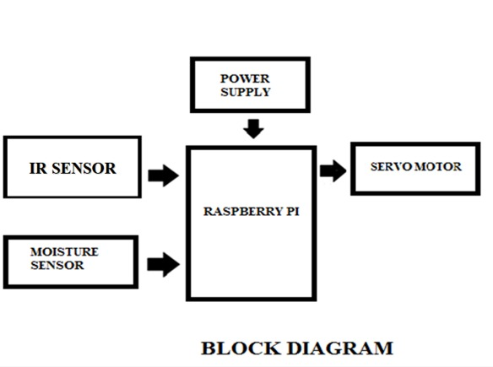

Fig2. Block diagram

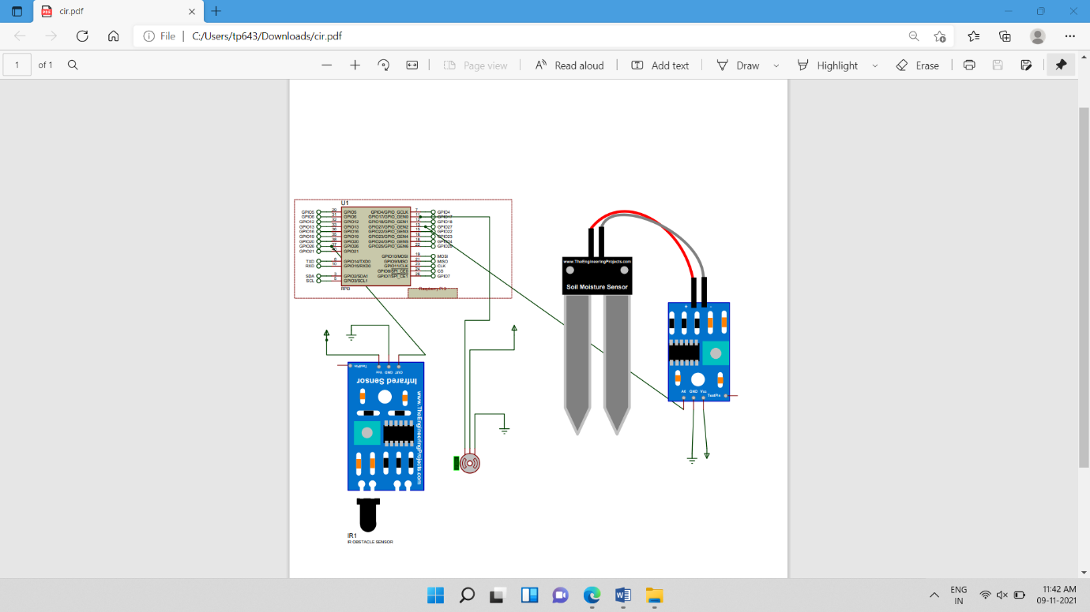

Fig 3 circuit diagram

**4) HARDWARE USED**

**4.1) Raspberry Pi :-**

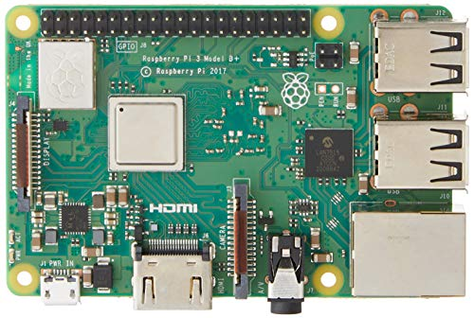

Fig 4. Raspberry Pi

The Raspberry Pi 3 Model B+ is the latest product in the Raspberry Pi 3 range, boasting a 64-bit quad core processor running at 1.4GHz, dual-band 2.4GHz and 5GHz wireless LAN, Bluetooth 4.2/BLE, faster Ethernet, and PoE capability via a separate PoE HAT The dual-band wireless LAN comes with modular compliance certification, allowing the board to be designed into end products with significantly reduced wireless LAN compliance testing, improving both cost and time to market. The Raspberry Pi 3 Model B+ maintains the same mechanical footprint as both the Raspberry Pi 2 Model B and the Raspberry Pi 3 Model B.

**Processor**: Broadcom BCM2837B0, Cortex-A53 64-bit SoC @ 1.4GHz

**Memory:** 1GB LPDDR2 SDRAM

**Connectivity:**

* 2.4GHz and 5GHz IEEE 802.11.b/g/n/ac wireless LAN, Bluetooth 4.2, BLE
* Gigabit Ethernet over USB 2.0 (maximum throughput 300Mbps)
* 4 × USB 2.0 ports

**Access:** Extended 40-pin GPIO header

**Video & sound:**

* 1 × full size HDMI
* MIPI DSI display port
* MIPI CSI camera port
* 4 pole stereo output and composite video port

**Multimedia:** H.264, MPEG-4 decode (1080p30); H.264 encode (1080p30); OpenGL ES 1.1, 2.0 graphics

**SD card support:** Micro SD format for loading operating system and data storage

**Input power:**

* 5V/2.5A DC via micro USB connector
* 5V DC via GPIO header
* Power over Ethernet (PoE)–enabled (requires separate PoE HAT)

**Environment:** Operating temperature, 0–50°C

**Compliance:** For a full list of local and regional product approvals, please visit www.raspberrypi.org/products/raspberry - pi-3-model-b+

**Production lifetime:** The Raspberry Pi 3 Model B+ will remain in production until at least January 2023.

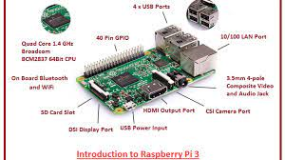

Fig 5. introduction to raspberry pi

**Pin configuration :-**

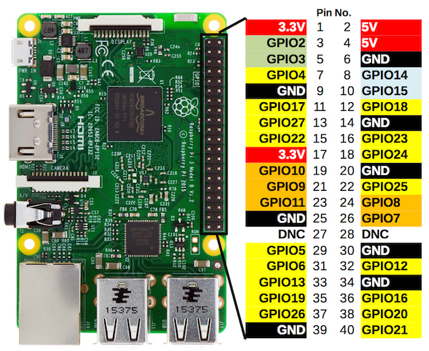

Fig 6. Pin configuration

GPIO stands for General Purpose Input Output pins these pins are used to connect the Raspberry pi board to external input/output devices. Like the previous model, model B+ also consists of a 40-pin GPIO. A standard interface for connecting a single-board computer or microprocessor to other devices is through General-Purpose Input/Output (GPIO) pins. As these pins don’t have a specific function, they can be customized using the software.  
Raspberry Pi 3 B+ Power Pins:

The model B+ board consists of two 5V pins, two 3V3 pins, and 9 Ground pins (0V), which are unconfigurable.

**5V**: The 5v pins are used to directly deliver the 5v supply coming from the mains adaptor. This pin can use to power up the Raspberry Pi, and it can also use to power up other 5v devices.

**3.3V**: The 3v pin is used to provide a stable 3.3v supply to external components and also to test LEDs.

**GND**: Ground is commonly referred to as GND. All the voltages are measured with respect to the GND voltage.

**Input/Outputs pins:**

A GPIO pin set as **Input** reads the signal received by the Raspberry Pi, sent by the device connected to this pin. Any voltage between 1.8V and 3.3V is read as HIGH and voltage lower than 1.8V as LOW by the Raspberry Pi.

**Note:** Do not connect a device with an input voltage above 3.3V to any of the GPIO pins, or else it will fry the Raspberry Pi.

A GPIO pin set as an **output** pin sends the voltage signal as high (3.3V) or low (0V). When this pin is set to HIGH, the voltage at the output is 3.3V and when set to LOW, the output voltage is 0V.Along with the simple function of input and output pins, the GPIO pins can also perform a variety of specific functions. Some specific pins are:

### **PWM (pulse-width modulation) Pins on Model 3B+:**

* + Software PWM is available on all pins
  + Hardware PWM is available on these pins only: **GPIO12, GPIO13, GPIO18, GPIO19**

**SPI Pins on Model 3B+ :**

SPI (Serial Peripheral Interface) is another protocol used for master-slave communication. It is used by the Raspberry pi board to quickly communicate between one or more peripheral devices. Data is synchronized using a clock (**SCLK** at GPIO11) from the master (RPi) and the data is sent from the Pi to our SPI device using the **MOSI** (Master Out Slave In) pin. If the SPI device needs to communicate back to Raspberry Pi, then it will send data back using the **MISO** (Master In Slave Out) pin. 5 pins are needed for the SPI communication:

* **GND**: Connect all GND pins from all the slave components and the Raspberry Pi 3 board together.
* **SCLK**: Clock of the SPI. Connect all SCLK pins.
* **MOSI**: It stands for Master Out Slave In. This pin is used to send data from the master to a slave.
* **MISO**: It stands for Master In Slave Out. This pin is used to receive data from a slave to the master.
* **CE**: It stands for Chip Enable. We need to connect one CE pin per slave (or peripheral devices) in our circuit. By default, we have two CE pins but we can configure more CE pins from the other available GPIO pins.

SPI pins on R-Pi Model 3B+ :

* + **SPI0:**GPIO9 (MISO), GPIO10 (MOSI), GPIO11 (SCLK), GPIO8 (CE0), GPIO7 (CE1)
  + **SPI1:**GPIO19 (MISO), GPIO20 (MOSI), GPIO21 (SCLK), GPIO18 (CE0), GPIO17 (CE1), GPIO16 (CE2)

**I2C Pins on R-Pi 3B+ :**

* I2C is used by the Raspberry Pi board to communicate with devices that are compatible with Inter-Integrated Circuit (a low-speed two-wire serial communication protocol). This communication standard requires master-slave roles between both the devices. I2C has two connections: **SDA (Serial Data)** and **SCL (Serial Clock)**. They work by sending data to and using the SDA connection, and the speed of data transfer is controlled via the SCL pin.  
  + **Data**: (GPIO2), Clock (GPIO3)
  + **EEPROM Data**: (GPIO0), EEPROM Clock (GPIO1)

**UART Pins on R-Pi 3B+ :**

Serial communication or the **UART** (Universal Asynchronous Receiver / Transmitter) pins provide a way to communicate between two microcontrollers or the computers. TX pin is used to transmit the serial data and RX pin is used to receive serial data coming from a different serial device.

* + TX (GPIO14)
  + RX (GPIO15)

## **Specifications of Model 3B+ :**

* Quad-Core 1.4GHz Broadcom BCM2837B0 64bit CPU
* 1GB LPDDR2 SDRAM
* Dual-channel 2.4GHz and 5GHz IEEE 802.11.b/g/n/ac wireless LAN, Bluetooth 4.2, BLE
* Gigabit Ethernet over USB 2.0 with throughput limited to 300 MB/s (3 times faster than model B)
* Extended 40-pin GPIO header
* Full-size HDMI
* 4 USB 2.0 ports
* Full-size HDMI CSI (Camera Serial Interface) camera port for connecting a camera
* DSI (Display Serial Interface) display port for connecting a touchscreen display
* 4-pole stereo output and composite video port
* Micro SD port
* 5V/2.5A DC power input
* Power-over-Ethernet (PoE) support (requires separate PoE HAT)

**4.2) Moisture sensor:-**

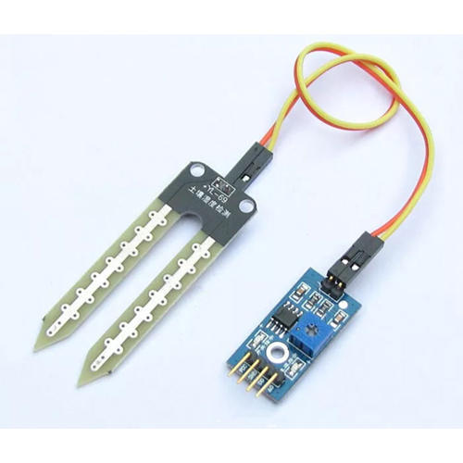

Fig 7. Moisture Sensor

The moisture of the soil plays an essential role in the irrigation field as well as in gardens for plants. As nutrients in the soil provide the food to the plants for their growth. Supplying water to the plants is also essential to change the temperature of the plants. The temperature of the plant can be changed with water using the method like transpiration. And plant root systems are also developed better when rising within moist soil. Extreme soil moisture levels can guide to anaerobic situations that can encourage the plant’s growth as well as soil pathogens. This article discusses an overview of the soil moisture sensor, working and it’s applications.

## What is a Soil Moisture Sensor?

The soil moisture sensor is one kind of sensor used to gauge the volumetric content of water within the soil. As the straight gravimetric dimension of soil moisture needs eliminating, drying, as well as sample weighting. These sensors measure the volumetric water content not directly with the help of some other rules of soil like dielectric constant, electrical resistance, otherwise interaction with neutrons, and replacement of the moisture content.

The relation among the calculated property as well as moisture of soil should be adjusted & may change based on ecological factors like temperature, type of soil, otherwise electric conductivity. The microwave emission which is reflected can be influenced by the moisture of soil as well as mainly used in agriculture and remote sensing within hydrology.

These sensors normally used to check volumetric water content, and another group of sensors calculates a new property of moisture within soils named water potential. Generally, these sensors are named as soil water potential sensors which include gypsum blocks and tensiometer.

**Soil Moisture Sensor Pin Configuration**

The FC-28 soil moisture sensor includes 4-pins

* VCC pin is used for power
* A0 pin is an analog output
* D0 pin is a digital output
* GND pin is a Ground

This module also includes a potentiometer that will fix the threshold value, & the value can be evaluated by the comparator-LM393. The [LED](https://www.elprocus.com/bipolar-led-driver-circuit-working-application/) will turn on/off based on the threshold value.

### Working Principle

This sensor mainly utilizes capacitance to gauge the water content of the soil (dielectric permittivity). The working of this sensor can be done by inserting this sensor into the earth and the status of the water content in the soil can be reported in the form of a percent.

his sensor makes it perfect to execute experiments within science courses like environmental science, agricultural science, biology, soil science, botany, and horticulture.

**Specifications**

The specification of this sensor includes the following.

* The required voltage for working is 5V
* The required current for working is <20mA
* Type of interface is analog
* The required working temperature of this sensor is 10°C~30°C

### Soil Moisture Sensor Applications

The applications of moisture sensor include the following.

* Agriculture
* Landscape irrigation
* Research
* Simple sensors for gardeners

**4.3) servo motor :- (sg90)**

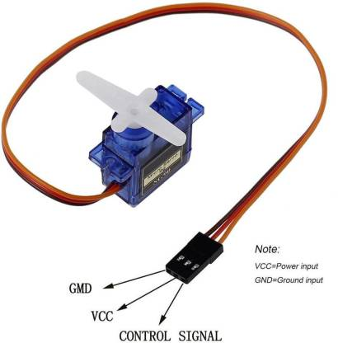

Fig 8. servo motor (sg90)

### **Servo Motor Wire Configuration**

|  |  |  |
| --- | --- | --- |
| **Wire Number** | **Wire Colour** | **Description** |
| 1 | Brown | Ground wire connected to the ground of system |
| 2 | Red | Powers the motor typically +5V is used |
| 3 | Orange | PWM signal is given in through this wire to drive the motor |

**SG-90 Features**

* Operating Voltage is +5V typically
* Torque: 2.5kg/cm
* Operating speed is 0.1s/60°
* Gear Type: Plastic
* Rotation : 0°-180°
* Weight of motor : 9gm
* Package includes gear horns and screws

### **SG-90 Servo Motor Equivalent**

[MG90S](https://components101.com/motors/mg90s-metal-gear-servo-motor) Metal Gear, [MG995](https://components101.com/motors/mg995-servo-motor) High Torque Metal Gear, VTS-08A Analog Servo

There are lots of [servo motors](https://components101.com/tags/servo-motor) available in the market and each one has its own speciality and applications. The following two paragraphs will help you identify the right type of servo motor for your project/system. Most of the hobby Servo motors operates from 4.8V to 6.5V, the higher the voltage higher the torque we can achieve, but most commonly they are operated at +5V.  Almost all hobby servo motors can rotate only from 0° to 180° due to their gear arrangement so make sure you project can live with the half circle if no, you can prefer for a 0° to 360° motor or modify the motor to make a full circle. The gears in the motors are easily subjected to wear and tear, so if your application requires stronger and long running motors you can go with metal gears or just stick with normal plastic gear. Next comes the most important parameter, which is the torque at which the motor operates. Again there are many choices here but the commonly available one is the 2.5kg/cm torque which comes with the Towerpro SG90 Motor. This 2.5kg/cm torque means that the motor can pull a weight of 2.5kg when it is suspended at a distance of 1cm. So if you suspend the load at 0.5cm then the motor can pull a load of 5kg similarly if you suspend the load at 2cm then can pull only 1.25. Based on the load which you use in the project you can select the motor with proper torque. The below picture will illustrate the same.

**How to use a Servo Motor:-**

After selecting the right Servo motor for the project, comes the question how to use it. As we know there are three wires coming out of this motor. The description of the same is given on top of this page. To make this motor rotate, we have to power the motor with +5V using the Red and Brown wire and send PWM signals to the Orange colour wire. Hence we need something that could generate PWM signals to make this motor work, this something could be anything like a 555 Timer or other Microcontroller platforms like Arduino, PIC, ARM or even a microprocessor like Raspberry Pie. Now, how to control the direction of the motor? To understand that let us a look at the picture given in the datasheet.

From the picture we can understand that the PWM signal produced should have a frequency of 50Hz that is the PWM period should be 20ms. Out of which the On-Time can vary from 1ms to 2ms. So when the on-time is 1ms the motor will be in 0° and when 1.5ms the motor will be 90°, similarly when it is 2ms it will be 180°. So, by varying the on-time from 1ms to 2ms the motor can be controlled from 0° to 180°

**Applications**

* Used as actuators in many robots like Biped Robot, Hexapod, robotic arm etc..
* Commonly used for steering system in RC toys
* Robots where position control is required without feedback
* Less weight hence used in multi DOF robots like humanoid robots

**4.4) IR sensor :-**

IR sensor is an electronic device, that emits the light in order to sense some object of the surroundings. An IR sensor can measure the heat of an object as well as detects the motion. Usually, in the [**infrared spectrum**](https://en.wikipedia.org/wiki/Infrared_spectroscopy), all the objects radiate some form of thermal radiation. These types of radiations are invisible to our eyes, but infrared sensor can detect these radiations.

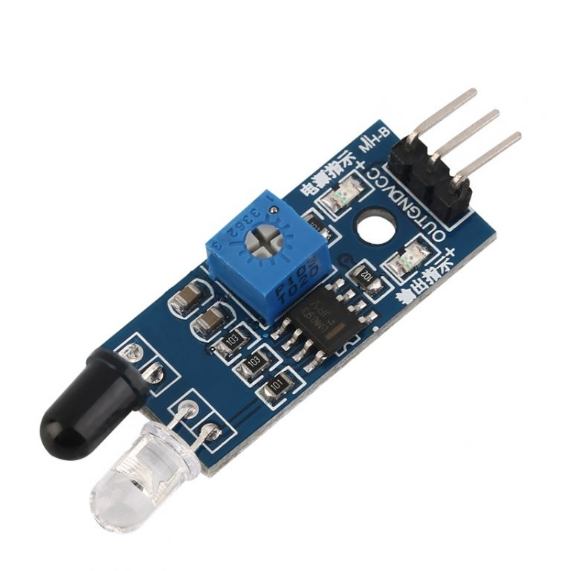

Fig 9. IR Sensor

The emitter is simply an IR LED (Light Emitting Diode) and the detector is simply an IR photodiode. Photodiode is sensitive to IR light of the same wavelength which is emitted by the IR LED. When IR light falls on the photodiode, the resistances and the output voltages will change in proportion to the magnitude of the IR light received.

There are five basic elements used in a typical infrared detection system: an infrared source, a transmission medium, optical component, infrared detectors or receivers and signal processing. Infrared lasers and Infrared LED’s of specific wavelength used as infrared sources.

The three main types of media used for infrared transmission are vacuum, atmosphere and optical fibers. Optical components are used to focus the infrared radiation or to limit the spectral response.

## **Types of IR Sensor**

There are two types of IR sensors are available and they are,

* Active Infrared Sensor
* Passive Infrared Sensor

### **Active Infrared Sensor**

Active infrared sensors consist of two elements: infrared source and infrared detector. Infrared sources include the LED or infrared laser diode. Infrared detectors include photodiodes or phototransistors. The energy emitted by the infrared source is reflected by an object and falls on the infrared detector.

### **Passive Infrared Sensor**

Passive infrared sensors are basically Infrared detectors. Passive infrared sensors do not use any infrared source and detector. They are of two types: quantum and thermal. Thermal infrared sensors use infrared energy as the source of heat. [**Thermocouples**](https://robu.in/product/max6675-thermocouple-sensor-module/), pyroelectric detectors and bolometers are the common types of thermal infrared detectors. Quantum type infrared sensors offer higher detection performance. It is faster than thermal type infrared detectors. The photo sensitivity of quantum type detectors is wavelength dependent.

## **IR Sensor Working Principle**

There are different types of infrared Transmitters depending on their wavelengths, output power and response time. An IR sensor consists of an IR LED and an IR Photodiode, together they are called as PhotoCoupler or OptoCoupler.

**IR Transmitter or IR LED**

Infrared Transmitter is a light emitting diode (LED) which emits infrared radiations called as IR LED’s. Even though an IR LED looks like a normal LED, the radiation emitted by it is invisible to the human eye.

[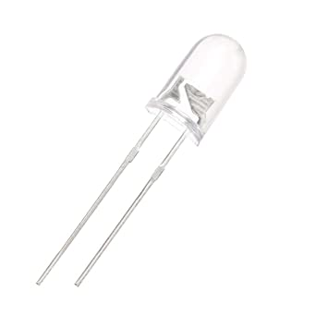](https://robu.in/wp-content/uploads/2020/05/51fibl-5xL._SX342_.jpg)The picture of an Infrared LED is shown below.

**Fig 10 .**Infrared LED

**IR Receiver or Photodiode**

Infrared receivers or infrared sensors detect the radiation from an IR Transmitter. IR receivers come in the form of photodiodes and phototransistors. Infrared Photodiodes are different from normal photo diodes as they detect only infrared radiation. Below image shows the picture of an IR receiver or a photodiode,

[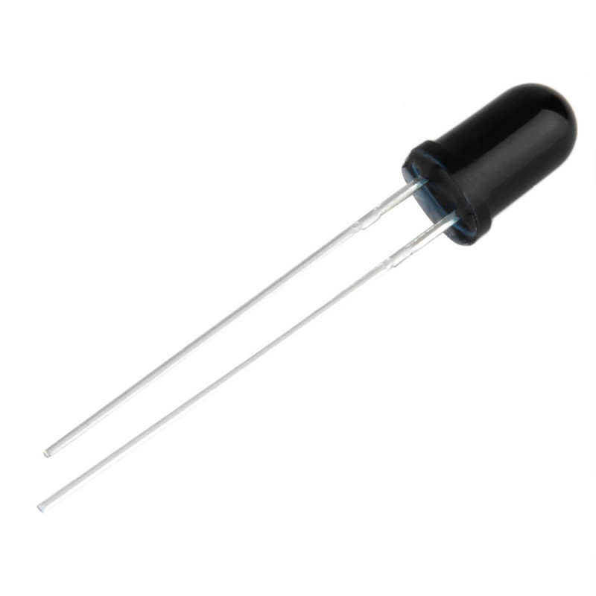](https://robu.in/wp-content/uploads/2020/05/SN-IR-R-0-1-1-800x800-1.jpg)

Fig 11**. IR Receiver**

Different types of IR receivers exist based on the wavelength, voltage, package, etc. When used in an infrared Transmitter – receiver combination, the wavelength of the receiver should match with that of the Transmitter.

[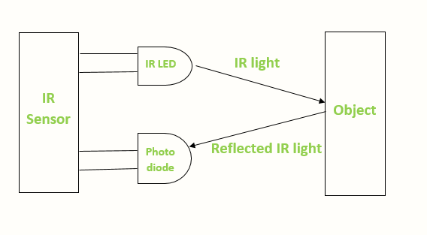](https://robu.in/wp-content/uploads/2020/05/IR-sensor-Working.png)The emitter is an IR LED and the detector is an IR photodiode. The IR photodiode is sensitive to the IR light emitted by an IR LED. The photo-diode’s resistance and output voltage change in proportion to the IR light received. This is the underlying working principle of the IR sensor.

Fig 12. IR sensor structure

When the IR Transmitter emits radiation, it reaches the object and some of the radiation reflects back to the IR receiver. Based on the intensity of the reception by the IR receiver, the output of the sensor defines.

**4.5 Breadboard & jumper wire:-**

A breadboard is used to build and test circuits quickly before finalizing any circuit design. The breadboard has many holes into which circuit components like ICs and resistors can be inserted. A typical breadboard is shown below:

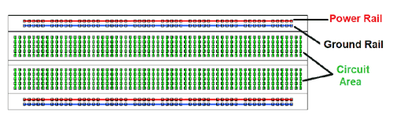

Fig 13. Breadboard

Breadboarding tips: It is important to breadboard a circuit neatly and systematically, so that one can debug it and get it running easily and quickly. It also helps when someone else needs to understand and inspect the circuit. Here are some tips:

1. Always use the side-lines for power supply connections. Power the chips from the side-lines and not directly from the power supply.

2. Use black wires for ground connections (0V), and red for other power connections.

3. Keep the jumper wires on the board flat, so that the board does not look cluttered.

4. Route jumper wires around the chips and not over the chips. This makes changing the chips when needed easier.

5. You could trim the legs of components like resistors, transistors and LEDs, so that they fit in snugly and do not get pulled out by accident.

**Jumper wires:-**

Jumper wires typically come in three versions: male-to-male, male-to-female and female-to-female. The difference between each is in the end point of the wire. Male ends have a pin protruding and can plug into things, while female ends do not and are used to plug things into. Male-to-male jumper wires are the most common and what you likely will use most often when connecting two ports on a breadboard.

**5) SOFTWARE USED**

**5.1) VNC**

VNC stands for Virtual Network Computing. It is a cross-platform screen sharing system that was created to remotely control another computer. This means that a computer’s screen, keyboard, and mouse can be used from a distance by a remote user from a secondary device as though they were sitting right in front of it.

VNC works on a client/server model. A server component is installed on the remote computer (the one you want to control), and a VNC viewer, or client, is installed on the device you want to control from. This can include another computer, a tablet, or a mobile phone. When the server and viewer are connected, the server transmits a copy of the remote computer’s screen to the viewer.

Not only can the remote user see everything on the remote computer’s screen, but the program also allows for keyboard and mouse commands to work on the remote computer from afar, so the connected user has full control (after being granted permission from the remote compute)r.

VNC was created in Cambridge in the late 1990s by the founders of [Real VNC](https://en.wikipedia.org/wiki/RealVNC), and was commercialized in 2002 when the company was established.

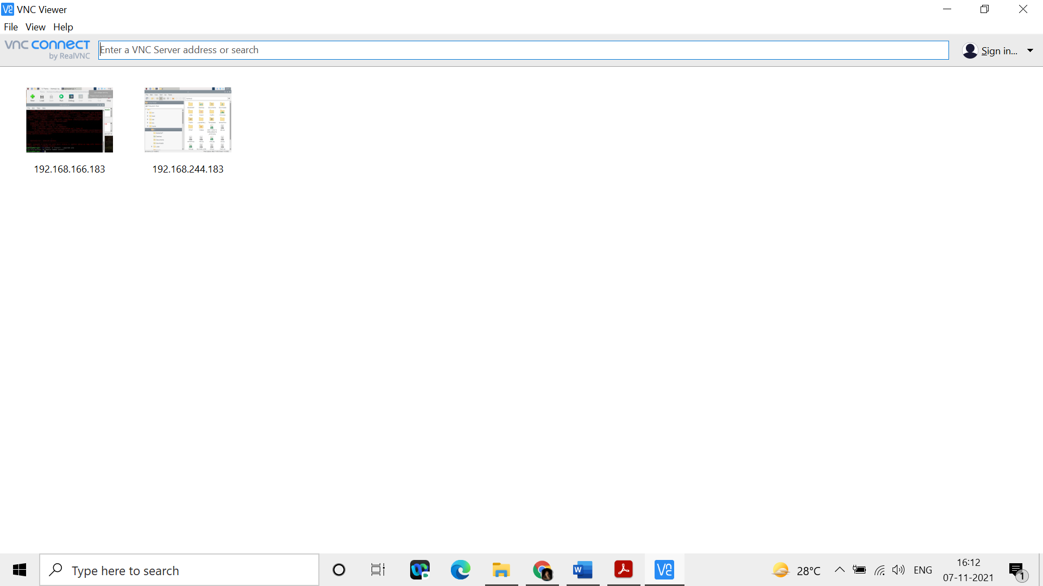

Fig 14.VNC

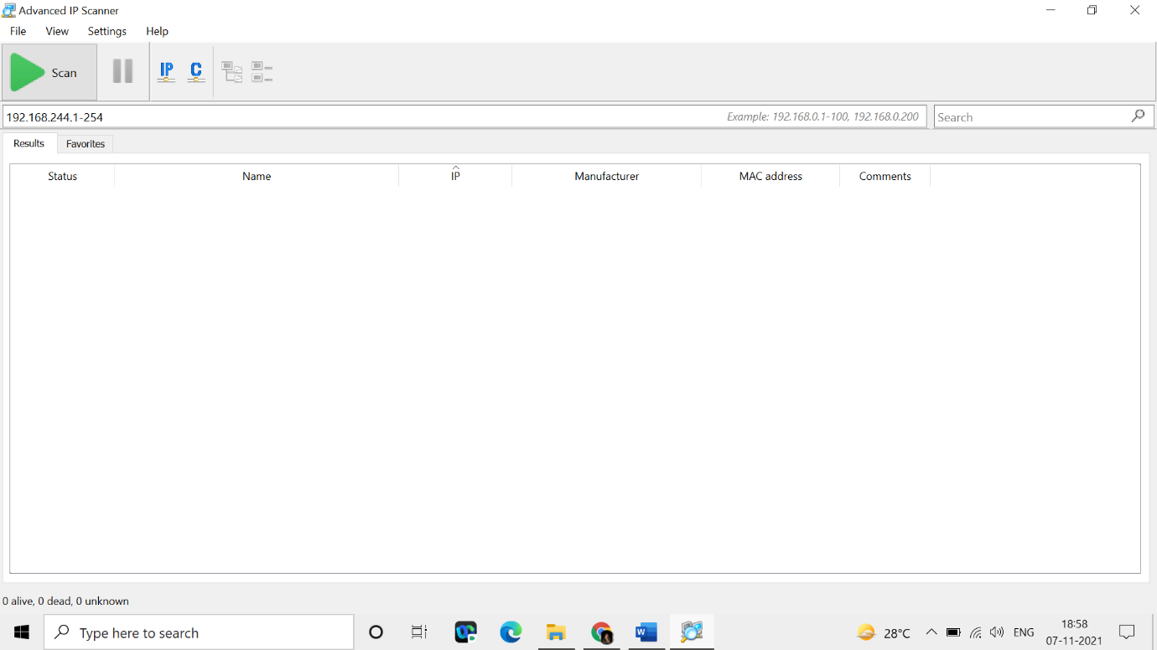**5.2) Advance IP scanner:-** To find the IP address of raspberry pi.

Fig 15. advance IP scanner

**5.3) balenaEtcher-Portable-1.5.122:-** A simple tool for flashing operating system.

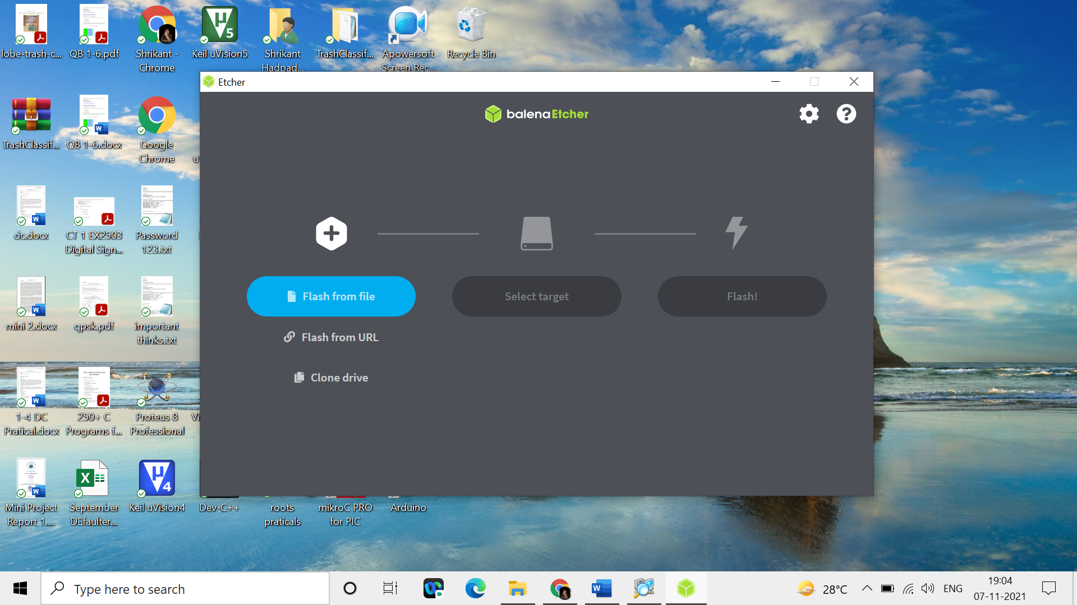

Fig 16. balenaEtcher-Portable

**6) RESULT**

**6.1) Methodology:-**

The main goal of the project is to design and develop a sorting system that sorts the waste automatically into three categories namely metal waste, wet waste, and dry waste. The system mainly consists of Raspberry Pi 3, IR sensor, moisture sensor and servo motors.

The waste is dumped into the Automatic Waste Segregator which marks the entry of the waste and starts up the system. It then initializes the sensor modules. The initialization of all modules ensures that any dynamic changes in the environment do not affect the sensing. As soon as the waste is dumped in to the system the ir sensor gets activated and recognizes that the waste is dumped.

The waste continues down the incline towards the moisture sensing module. Moisture sensor identifies whether the object is dry or wet. If the moisture level of the object is high then the object is identified as wet waste or else dry waste. To achieve the segregation, a servo motor is used. The containers are placed on a circular base which is mounted on the axle of a servo motor. The circular base rotates as the axle of the servo motor rotates.. The servo motor is given three different positions or angles for the two types of wastes detected. The motor thus always comes to the required position according to the signal obtained. The default bin at the circular base is the dry bin. To avoid overshooting of the container due to the momentum of the base, the servo motor is rotated at lower speeds by using pulse width modulation (PWM) which is generated from the Raspberry pi. Thus the segregation is completed.

Basic work from the raspberry pi 3 when waste dumped on the waste pad on that time ir sensor senses the waste. After the moisture sensor sense the moisture. If moisture is present the it’s wet waste other wise dry. (Default its dry waste.)

**6.2) Code:-**

import RPi.GPIO as GPIO

import time

servom =17

outPin = 5

inPin = 27

ir = 26

GPIO.setwarnings(False)

GPIO.setmode(GPIO.BCM)

GPIO.setup(servom, GPIO.OUT)

GPIO.setup(outPin, GPIO.OUT)

GPIO.setup(inPin, GPIO.IN)

GPIO.setup(ir, GPIO.IN)

pwm= GPIO.PWM(servom,50)

pwm.start(servom)

def dutycycle(dp):

for i in range (0, 1):

dc = 1. / 18. * (dp) + 2

pwm.ChangeDutyCycle(dc)

while(1):

value = GPIO.input(inPin)

state= GPIO.input(ir)

dutycycle(90)

if(state == 0):

value = GPIO.input(inPin)

print("value", value)

if(value == 1):

time.sleep(5)

print("45", value)

dutycycle(45)

elif(value== 0):

time.sleep(5)

print("135", value)

dutycycle(135)

pwm.stop()

GPIO.cleanup()

**6.3)Output:-**

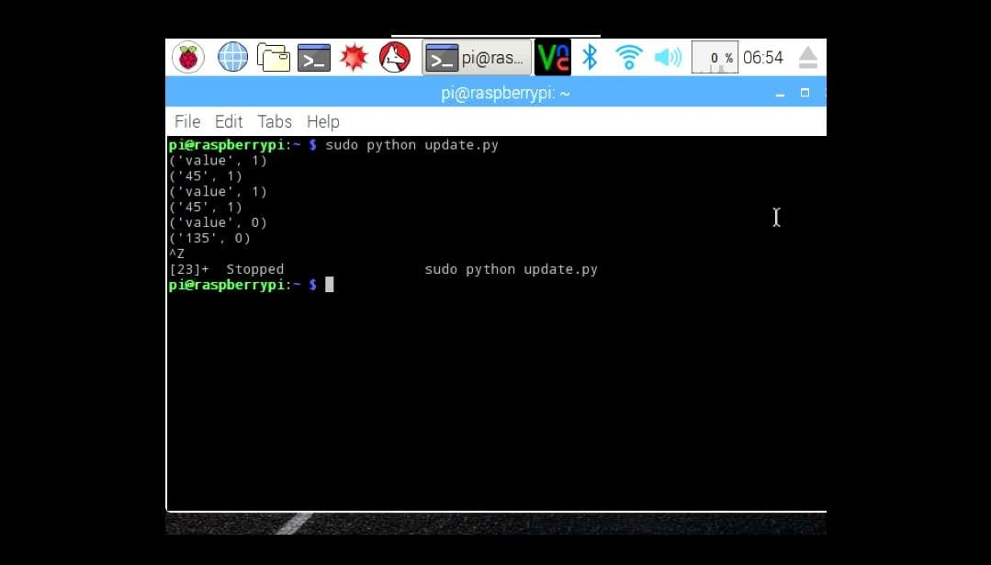

Fig 17. Terminal window output

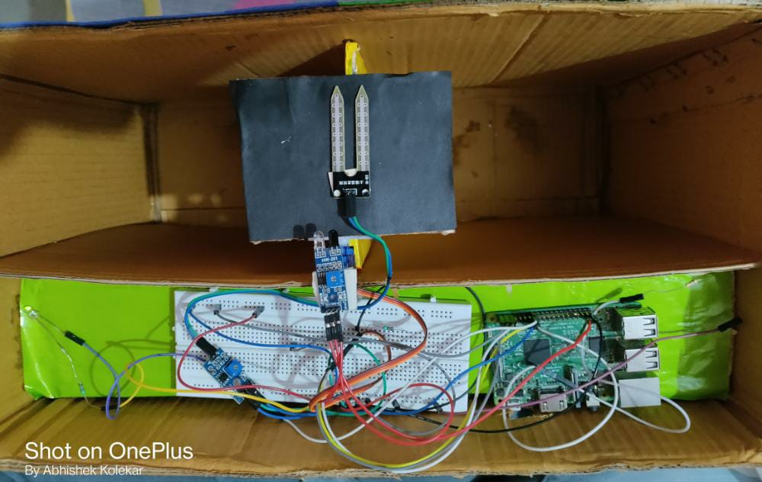

Fig 18. Hardware output

**7) CONCLUSION**

Dry and wet Waste Segregator has been successfully implemented for the segregation of waste into dry and wet waste at a domestic level. The system can segregate only one type of waste at a time with an assigned priority for wet and dry waste. The experiment has been conducted for wet, dry wastes. It is found that the change of moisture value is greater for wet waste and very less for dry waste. Other objects like glass and wood have intermediate relative dielectric constant and thus are detected as dry waste. Experimental result shows that the waste has been successfully segregated into wet and dry using the Waste segregator. Redesigning old dustbin into multiple system fulfil customer needs and requirements. We believe that this model can change community’s mind set to throwing the garbage. The smart waste segregation improves the garbage collection system implemented across the country with less human intervention.

**8) REFERENCES**

1. Raspberry Pi Official Beginner's Guide Second edition

2.M.K.Pushpa, Aayushi Gupta, Shariq Mohammed Shaikh, Stuti Jha, Suchitra V, “Microcontroller based Automatic Waste Segregator”, IJIREEICE, Volume 3, Issue 5, May 2015.

3. <http://www.ijrat.org/downloads/Vol-4/july-2016/paper%20ID-47201638.pdf>

4. <http://www.ijireeice.com/upload/2015/may-15/IJIREEICE%2029.pdf>

5. Ruveena Singh, Dr. Balwinder Singh, “Design and Development of Smart Waste Sorting System”, IJRECE, Volume 3, Issue 4, December 2015.